|  |
| --- |
| Assignment 3&Group Work |
| Can You Trust IT? |
| BIT 106 |

|  |
| --- |
| S20222500 Rongzhen Zhou SE20232784 Jieyan Liang SE20212131 Yule Xiao  2023-5-23 |

Catalogue

1. Introduction 1

2. Background 1

2.1 online banking 1

2.2 Online Purchasing 3

3. Analysist 5

3.1. Online Banking 5

3.2. Online Purchasing 7

4. Conclusion 9

5. Reference 11

# Introduction

In this group assessment, we will provide an analytical report about a contemporary issue in ICT from the ethical perspective, given the “Can you trust IT” as the topic of this report.

In the topic “Can you trust IT”, we will mainly analyze the issues about the online banking and online purchase. We will divide our assessment into three parts, Background, Analysist and Conclusion. In the Background, we are going to talk about the essentially information of the online banking and online purchasing and the advantages and disadvantages of the online banking and online purchasing. In the Analysist, we are going to analyze the legal, ethical and social issues given the support of the detailed data. In the Conclusion, we are going to give a conclusion for this assessment.

# Background

## Online Banking

Over the past few years, as technology has permeated everyday life, more and more people are using online banking to easily manage their finances from the comfort of their own home or on the go. According to an article published in the Official Library of the United States, the future of banking is that "banking is not just a place, it is a behaviour”[1]. Furthermore, statistics show that the number of internet users worldwide is increasing and will continue to do so in the future. [2]

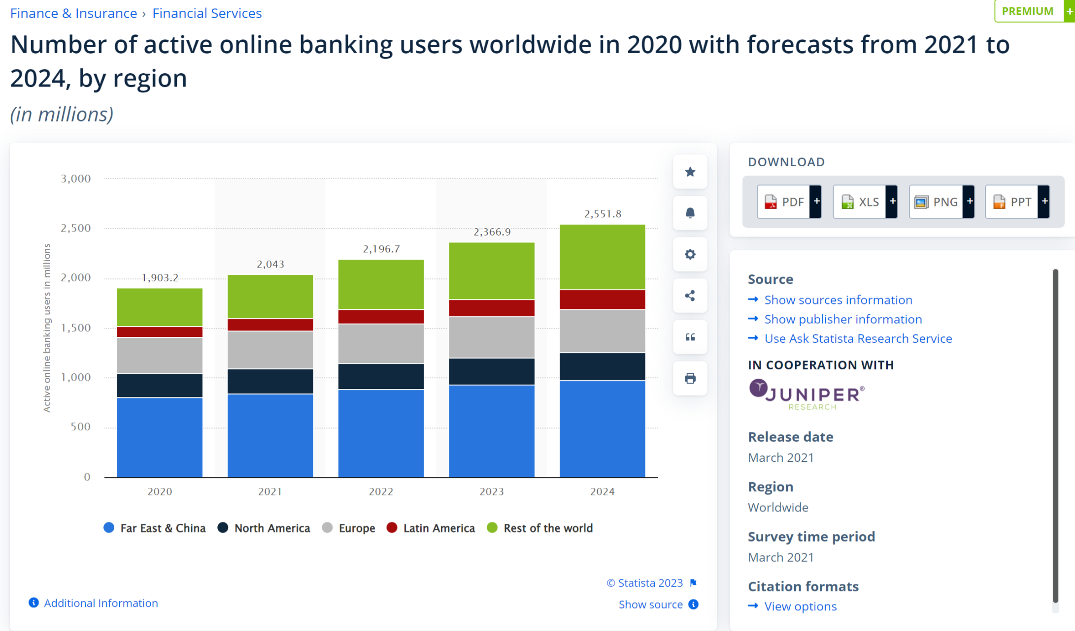

（Image credit to Statista）

Firstly, online banking offers unrivalled convenience, enabling people to access their accounts and carry out a wide range of transactions at any time. This convenience is particularly useful for those with busy schedules and difficulty travelling.

Secondly, online banking is characterized by the reliability and security of the connection process. Data encryption, access control, blocking of unauthorized users by trusted third parties, authentication methods such as name and password identification, network traffic monitoring by firewalls, intrusion detection and prevention (ID) systems, anti-virus software and much more. Security mechanisms used. [3] By securing its own systems, banks also ensures the security of its customers' information.

Moreover, online banking provides improved convenience as it enables individuals to check their accounts from any location with access to the internet, regardless of whether it's through their personal computer or mobile device. This convenience is especially advantageous for people who commute frequently or reside in extreme regions where traditional banking services may be scarce.

Even with security measures in place, online banking is not immune to security breaches. Cybercriminals can get hold of confidential details like account numbers, passwords and financial data, which can result in identity theft and fraudulent activities. This was demonstrated in February 2016 when hackers targeted the central bank of Bangladesh and found a loophole in SWIFT, the primary electronic payment information system for the global financial system. Their aim was to steal $1 billion, but although majority of the transactions were prevented, they still managed to steal $101 million. [4]

Concurrently, the use of online banking presents obstacles for the elderly. This demographic group may experience challenges when attempting to adjust to new technological devices and intricate digital interfaces. The swift progression of technology can make it strenuous for them to stay abreast of the shifting online banking system. Furthermore, diminutive text, jumbled arrangements, and unfamiliar symbols may hinder their ability to comprehend and properly utilize online banking features. Data indicates that senior citizens utilize Internet banking less frequently than other age groups.

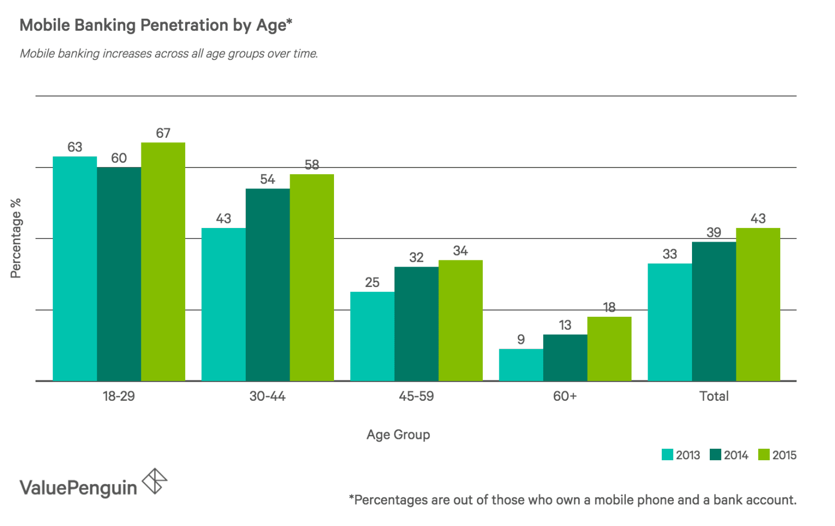

（Image credit to value penguin）

## Online Purchasing

Online shopping has undoubtedly become a unique part of human life. The online shopping industry has created many jobs, interrupted the traditional exchange of goods and inspired the growth of information technology: In 1979, the first version of e-shopping was invented; in 1979, the first online shop was opened in the UK. In just under 50 years, however, online shopping has grown to $640 million, with well-known companies such as Amazon and Alibaba [5].

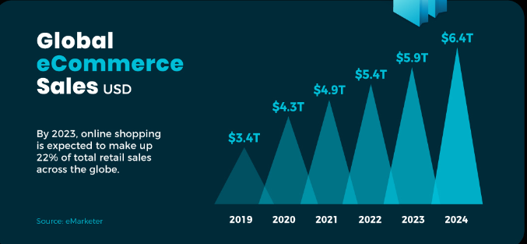

Firstly, convenience.[6] This is the main benefit and value of online shopping. Online shopping centers offer a platform where customers can easily choose their preference products. Customers can place an order in minutes or seconds.

Another advantage of online shopping is that it is available 24 hours a day. Most physical stores close after less than 24 hours. Online stores, on the other hand, are open all day. Online shoppers can therefore shop at any time of the day.

In short, after more than 40 years of development, consumers are increasingly relying on the benefits of online shopping.

Secondly, better prices. [7] Online shops offer their customers a wide range of products. During holidays and festivals, online shops offer their customers huge discounts, sales and coupons. Online shops also organise flash sales so that online shoppers can get goods and services at the best prices.

However, online shopping also has its drawbacks.

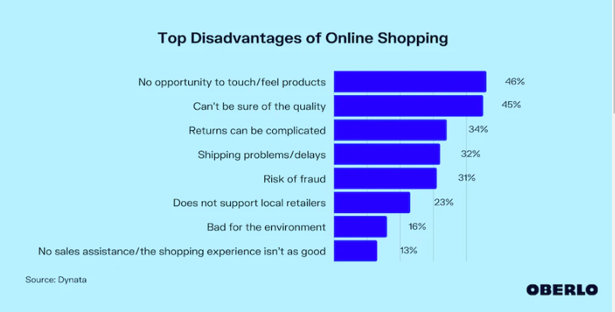

Firstly, in a recent survey, the biggest disadvantage associated with online shopping was the inability to physically touch the goods. [8] 46% of consumers surveyed identified this as a disadvantage of shopping online.

Secondly, the inability to determine quality.[9] The second major disadvantage of online shopping is somewhat related to the first, 45% of consumers say that shopping online is a trouble if they are not sure of the quality of the merchandises they buy.

# Analysist

## Online Banking

The arrival of the Internet bank has transformed our method of financial management, which provides us with the advantages of convenience, security, barrier-free and so on. However, there are many legal, moral and social considerations for all technological innovations.

From a legal point of view, there are kinds of regulations about Internet banking. In order to protect the security of customer information, banks should comply with the data Protection and Privacy Law, such as the data Protection Act [10]. If you fail to comply with the above terms, you will be severely punished, ranging from a fine to a prosecution. In addition, the cyber security regulations require major banks to establish a sound security system in agreement with laws relating to consumer rights and interests in order to maintain fair trade and customer rights.

From an ethical point of view, privacy is the principal concern. Online banking forces the gathering and retention of large quantities of personal and financial data, thus raising questions about the ethical management and protecting of this information. Program security is compromised, and the risk of identity theft pose considerable challenges that can undermine customer trust and ethical concerns.

Looking at it from a social standpoint, the proliferation of online banking has both its benefits and drawbacks. On the one hand, it has paved the way for better access to financial services, especially for individuals living in remote or hard-to-reach areas. It has simplified banking processes, allowing customers to handle their finances more efficiently, and has opened up financial opportunities for more people. However, it has likewise widened the digital gap, leaving out sectors of society with no access to technology or limited knowledge of digital literacy. As per research (Sun S et al.)[11], financial access should aim to promote financial inclusion to provide safe, manageable, applicable, and convenient financial products and services to everyone in society. These inequalities run contrary to what the research suggests, deepening social inequalities and marginalizing certain groups, which can lead to exclusion and prejudice.

To minimize the impact of these concerns, several recommendations can be considered. Firstly, banks should prioritize robust security measures, such as encryption, multi-factor authentication, and fraud detection systems. With the use of advanced technology, theoretical advancements, and practical implementations, they can integrate agile solutions to improve privacy protection and data analysis and sharing security. (Kuo TT et al.)[12] Secondly, transparency and informed consent are indispensable. Banks must clearly communicate their data regulations and obtain customer approval for data sharing. This transparency establishes trust and ensures customers' autonomy over their private information.

In addition, increase the training and support of users also the key to dealing with the privacy of users' personal data and improving the security of users to Internet banking. Banks should provide support and guidance to customers, especially those with low level of digital education. In addition, to ensure fair use, there must be an inclusive online financial platform to consider a diversity of functional and barrier-free requirements. This is particularly essential. In the environment of the data transmission technology center, the data collected by the data transmission technology center is subject to the European General data Protection rules (GDPR) and privacy laws of the United States (such as the California Consumer Privacy Act, the California Consumer Privacy Act or the Virginia Consumer data Protection Act). These laws are made to facilitate use (such as data use agreements, privacy policies, or business terms).[13] Thus, banks need to keep up with national data protection, privacy, cyber security, and consumer protection regulations, and work with governors and industry stakeholders to develop best practices on new dangers. With established a standard security system. Through the implementation of the above measures, banks will be able to enhance the flavor, reciprocal trust and transparency of online banking business at the moral, legal and social levels, and protect the privacy and security of customer data.

## Online Purchasing

Generally, the online purchasing is a product that collects thousands of technologies, like Information encryption technology, the online payment technology, etc. As artificial product, it cannot work perfectly without any problems.

Firstly, Information disclosure. As we all know that, you need to provide many information, including address, bank card, personal information, while you purchasing online. According to a report that, at least 80% of shopping Apps leak users’ data, and nearly 60 million Americans have been victims of fraud or identity theft resulting from a breach of their personal information.[14] The reason why the user easily leaks their data is that some websites don’t encrypt data, and they operate on outdated SSL certificates and HTTP protocols which make them vulnerable to attacks.

Is this this behavior legal?

1) Honestly, many companies will let you check in advance now indicate will you agree to the terms of the privacy of personal information to use elsewhere, from the point of view, it is not illegal. This breaching strategy leaks user’s sensitive information to an extensive network of third parties, who can then use the data to create targeted advertisements based on your online behavior and preferences.[15]

2) However, will still have a few companies directly reveal the user personal information in order to seek profits, which is apparently illegal. Such like the Lord & Taylor, Saks Fifth Avenue.[16]

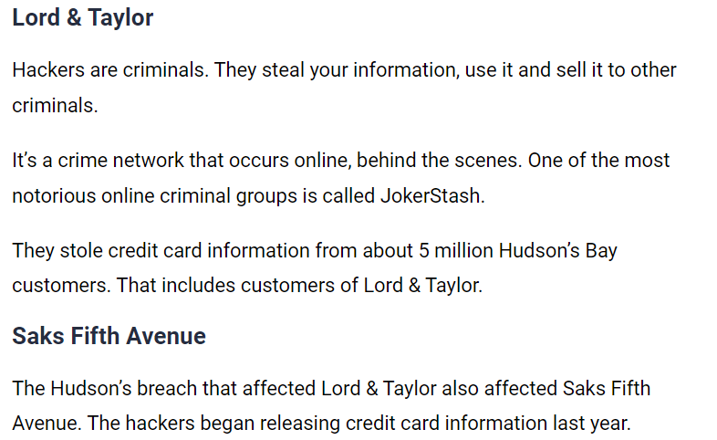

In China, in order to organize this kind of illegal and criminal behavior, and introduced a series of laws.[15]

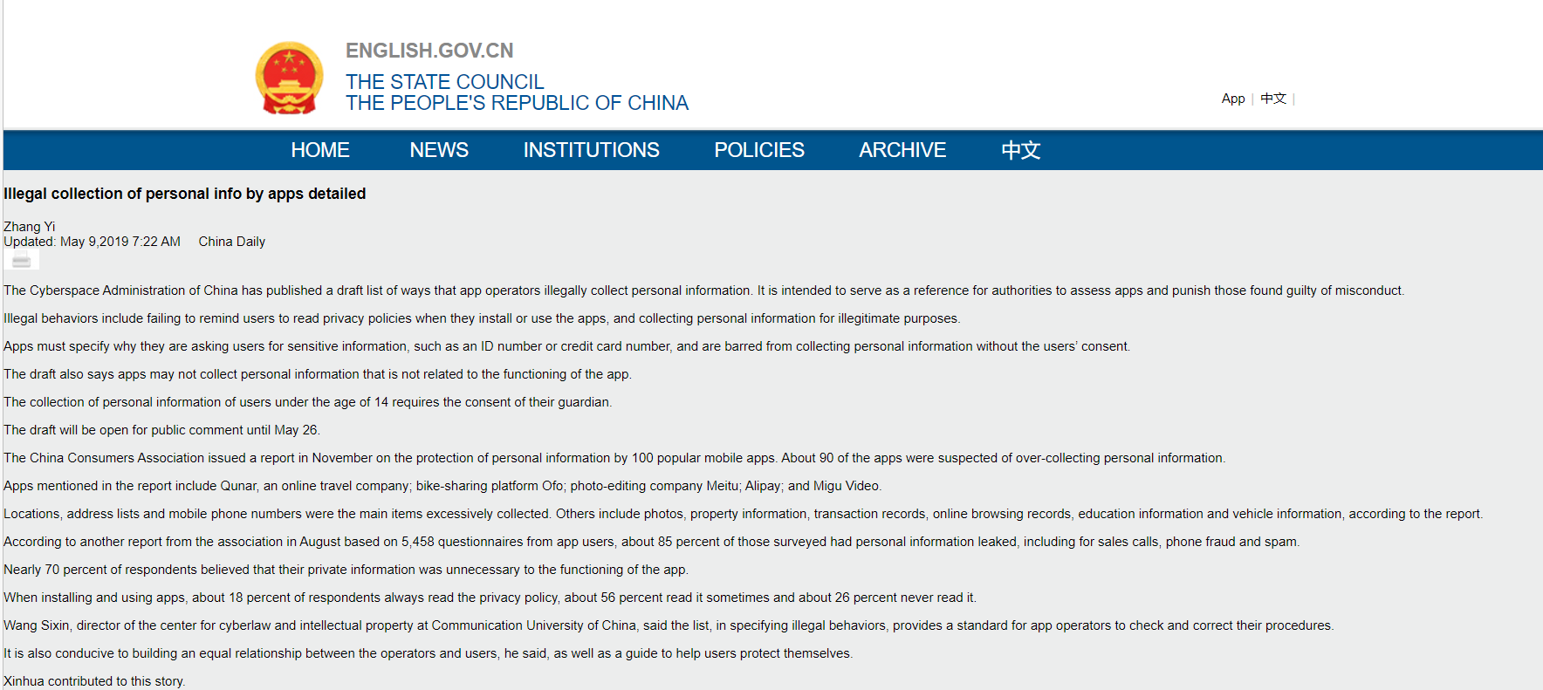

Is this behavior ethical?

Obviously, it is unethical. Online shopping site or application have an obligation to protect the user's personal information safety, once appear, personal information leakage. It may cause serious consequences, including to Lawsuits, Loss of business clients and relationships, Termination of employment and more, Criminal charges, etc.

What is the social influence of this behavior?

1) To people, Information will greatly affect people's normal life, so people may gradually lose confidence in online shopping.

2) To companies, People lost confidence in online shopping, no doubt, is a deadly blow to online shopping company. It may directly cause the company credibility, as well as the revenue decline

3) To the whole society, when criminals see after selling the information to make a profit, might increase the occurrence of this phenomenon.

How to reduce it?

1) To people, People should try to learn how to prevent leaks of information in online shopping. Simple learning laws at the same time, when the information leakage occurs, how should maintain their own power.

2) To companies, Company should increase investment in site security related to prevent hackers or invasion of criminals stealing users' personal information.

At the same time the company should be to perform duties to protect users' personal information.

3) To the whole society, Society should intensify propaganda to protect the privacy of personal information, at the same time issued relevant laws and regulations on information disclosure

# Conclusion

A wealth of research has shown that focusing on online banking and shopping is an integral part of our lives and can cause significant harm. However, it's important to remember that not all large organisations, such as Chat-GPT are perfect in all areas of life. Countries and departments such as China are introducing laws and regulations to improve network security. As the saying goes, the development of information technology is not accidental, but the result of deliberate efforts and continuous improvement. While recognizing the limitations of information technology, it is important to recognize that technological advances are accompanied by an increase in security measures. Philosopher Thomas Hobbes wisely points out that "curiosity is the desire of the mind that drives us to take risks, but prudence is the virtue that ensures our safe passage to our destination". The risks of online banking and shopping can be minimized by using a cautious and prudent approach.

Awareness and education about cybersecurity are also key. The responsibility to protect rests with individuals, institutions and Governments. Mahatma Gandhi said: "The future depends on what we do now. By supporting collective cybersecurity efforts, we can contribute to creating a more secure digital environment.

Overall, full confidence in information technology can be challenging, but efforts to enhance network security continue. Acknowledging potential mistakes and adopting an active cybersecurity practice will allow us to benefit from online banking and online shopping while minimizing risk. Albert Einstein once remarked, ``The measure of intelligence is the ability to change." By adapting and persevering, we can build a more trustworthy and secure IT environment.

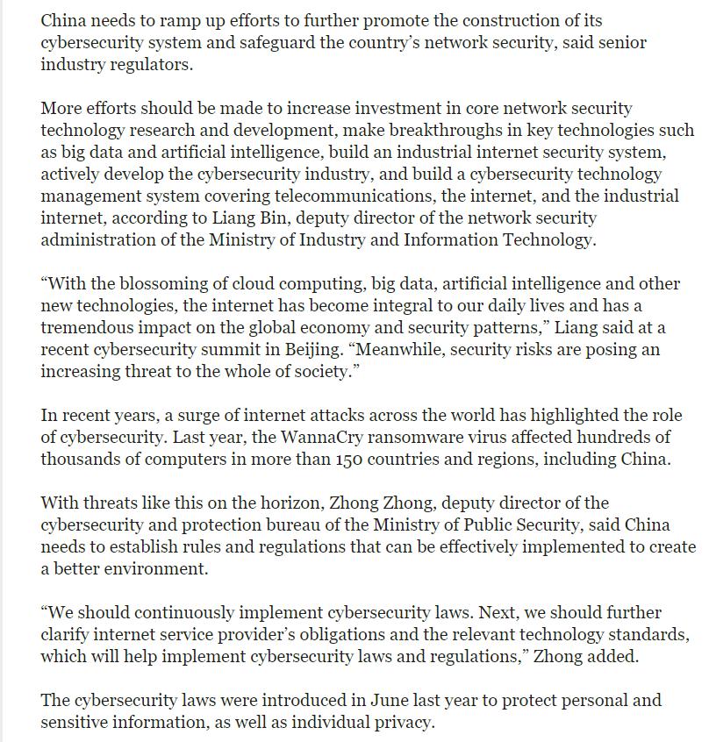

Across the IT industry, the market share for network security is growing. [17] This indirectly reflects the importance of the network security industry to the entire information industry. This will inevitably lead to technological advancement and increase network security construction.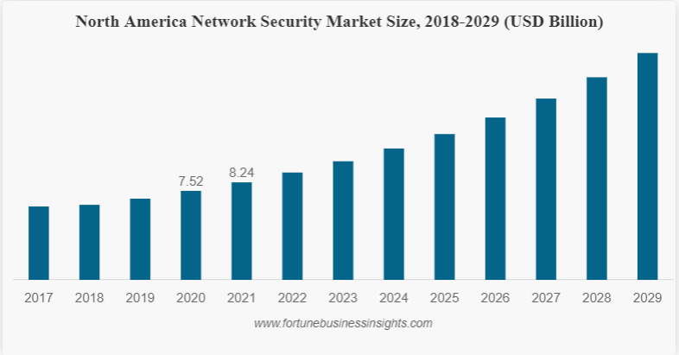

Therefore, although IT cannot achieve 100% security, at least it is striving towards 100%.

# References

1. R., Wang, Y.H., Hung, Y.M. (2020). Analyzing the factors influencing adoption intention of internet banking: Applying DEMATEL-ANP-SEM approach. PLoS One, 15(2), e0227852. doi: 10.1371/journal.pone.0227852.
2. Atista. (n.d.). Online banking users worldwide by region. Retrieved from [URL]
3. Alzoubi, Y.I., Gill, A.Q., Anwar, M.J. (2022). Cybersecurity Enterprises Policies: A Comparative Study. Sensors (Basel), 22(2), 538. doi: 10.3390/s22020538.
4. Ternational Monetary Fund. (n.d.). The Global Cyber Threat to Financial Systems. Finance & Development. Retrieved from [URL]
5. Eng, C. (2021, July 5). Timeline: Key Events in the History of Online Shopping. Retrieved from [URL]
6. Hukwuemeka, E.S. (2021, August 1). 7 Advantages and Disadvantages of Online Shopping. Retrieved from [URL]
7. Berlo. (n.d.). Disadvantages of Online Shopping. Retrieved from [URL]
8. European Union. (2016). General Data Protection Regulation (GDPR) Compliance Guidelines. Retrieved from [URL]
9. Un, S., Chen, Y.C., Ansong, D., Huang, J., Sherraden, M.S. (2022). Household Financial Capability and Economic Hardship: An Empirical Examination of the Financial Capability Framework. Journal of Family and Economic Issues, 43(4), 716-729. doi: 10.1007/s10834-022-09816-5.
10. Kuo, T.T., Jiang, X., Tang, H., Wang, X., Harmanci, A., Kim, M., ... Ohno-Machado, L. (2022). The evolving privacy and security concerns for genomic data analysis and sharing as observed from the iDASH competition. Journal of the American Medical Informatics Association, 29(12), 2182-2190. doi: 10.1093/jamia/ocac165.
11. Wan, Z., Hazel, J.W., Clayton, E.W., Vorobeychik, Y., Kantarcioglu, M., Malin, B.A. (2022). Sociotechnical safeguards for genomic data privacy. Nature Reviews Genetics, 23(7), 429-445. doi: 10.1038/s41576-022-00455-y.
12. Langone, A. (2019, November 27). At Least 80% of Shopping Apps Leak Users' Data. Here's How to Protect Yourself. Retrieved from [URL]
13. Author not provided]. (2022, September 19). 8 Out of 10 Websites Are Leaking User Searches to Advertisers: How to Protect Your Privacy Online. Retrieved from [URL]
14. Downey, K. (2019, February 16). Your data may have been stolen from these 10 companies. Retrieved from [URL]
15. Zhang, Y. (2019, May 9). Illegal collection of personal info by apps detailed. China Daily. Retrieved from [URL]
16. Ouyang, S., Yang, J. (2018, September 7). Regulators urge further security efforts to safeguard network. China Daily. Retrieved from [URL]
17. Fortune Business Insights. (n.d.). Network Security Market Size, Share & COVID-19 Impact Analysis, By Component (Solutions, Services), By Deployment Type (Cloud, On-premises), By Organization Size (SMEs, Large Enterprises), By Vertical (BFSI, IT and Telecommunications, Healthcare, Government, Retail, Manufacturing, Others), and Regional Forecast, 2022-2029. Retrieved from [URL]